Ben Robinson

R020140g@student.staffs.ac.uk

Group Game Development Project and Work Based Simulation

Written Assignment

Contents

1. Introduction 1

2. PlayStation (PS1) – A great success 1

2.1. Background 1

2.2. Marketing 1

2.3. PS1 Controller 1

2.4. Effect on Sony and future releases 1

2.5. Games on the PS1 1

3. The Wii U – A comparative failure 1

3.1. Background on the game and franchise 1

3.2. Marketing Campaign 1

3.3. Lack of new games 1

3.4. Effect on Nintendo and future releases 1

4. Conclusions: 1

4.2. A new console 1

4.3. Third Party Support 1

Bibliography 1

Appendices 1

Appendix 1: PlayStation Controller 1

Appendix 2: DualShock Controller 1

# Introduction

* 1. This assignment examines the comparative success of Sony’s PlayStation 1 (PS1) in 1995 (102 million sales) with Nintendo’s Wii U console in 2012 (13 million sales); their impact on society, the games industry and the inter relationship between console and game success. It considers their failure/success from a project management perspective, how did considerations of what the market wanted from a games perspective influence their marketing approach?
  2. Not only was the PS1 a major success, so were its games, it established Sony as perhaps the most important player in the market, changed the games industry forever and arguably society. Encouraging more people to play games to such an extent that the games industry is now larger than the film industry (Stewart, 2019). The release of subsequent consoles; the PlayStation 2, 3 and 4 and soon to be released PlayStation 5 becoming major events in the gaming calendar.
  3. The Wii U, although having some great games, was seen as a comparative flop in comparison to the ground breaking PS1. Why was this? Nintendo were an established games company and Sony were a new entrant to the market. Was it the marketing? Nintendo’s arrogance – we release a new console and it sells? The games or something else? In determining the reasons, comparisons are made between commercial success, overall sales, the marketing approach, the key differences between the consoles with the rest of the market and looks at the success or otherwise of some of their games. Were the games flops because they just weren’t very good enough or did the games developer just choose the wrong console? What were key factors?
  4. Within the games industry, the release of a games console is an exciting time for developers, a new product offering something new to the market means an opportunity to develop and sell new games. Both for the games developers who helped create the console, hoping to make a profit from the release and third party developers who can use the console to promote their newly released games onto the platform. The failure of a console to sell will mean third party developers will not want to develop games for it, which in turn means consumers will buy other consoles. This means that the inter relationship between the two is different from other industries in that the company releasing the new console, even though it has its own in-house games development team knows that it needs third party developers to develop other games as well so will encourage and incentivise them. Both either succeeding or failing based on the others approach.

# PlayStation (PS1) – A great success

### Background

* + 1. Sony released their first games console, the PS1 in Japan on the 3rd December 1994, followed by a 9th September 1995 release in America and 29th September 1995 in Europe. The console sold 102 million units and led to the creation of the PlayStation 2 which sold over 155 million units, still the highest grossing games console of all time (Richer, 2020). The main reason for this was differentiation from the rest of the console market at the time.
    2. Originally designed to be CD-ROM attachment to the Super Nintendo Entertainment System (SNES) the deal for the attachment fell through leading to Nintendo to partner with Philips for the failed attachment known as the Philips CDI while Sony modified their initial prototype into the PS1. If this deal had not fallen through it is unknown whether the games industry would have changed the same way it had from the PS1’s release *(Donovan, 2018)*.
    3. The PS1 was one of the first console to have games released on CD, it boasted advanced 3D polygon graphics (Sony, n.d.)and it also had a new, unique, controller. As well as these differences it was the first console to focus on third party, rather than first party games. Not only did this improve its value to consumers it changed how the market was perceived. Looking back this was a gamble, hardware by its nature has high raw material and production costs. Whereas when up and running game sales are nearly all profit. Why sacrifice the profits from games sales for other companies? Sony’s gamble paid off, not only was its console much more powerful than the others in the market but by opening up to independent developers, relying on licencing fees and console sales meant consumers had improved choice which in turn meant they bought the console and more games. By taking a big share of the market early on future sales took care of themselves.
    4. Sony know when their console is falling behind the market and so are always ready to release a new one but they don’t forget the basics of the ground breaking PS1. The market differentiation required when they release a new console and enough new third party games ready on release to encourage consumers it is worth buying. What’s the point of having a great console without a wide enough choice of games to choose from?

## Marketing

* + 1. When the PS1 was released, game consoles were primarily produced by Nintendo and SEGA which were mainly focused on their large first party catalogue of games. While there were many third-party developed games available on the consoles they were not as popular as the first party games. With the release of the PS1 there was a large focus on third party releases. 1,300 games were released onto the platform *(List Challenges, n.d.)* by the end of the consoles life span. Many of which were exclusive to the PS1. With its focus on third party games, many companies decided just to publish games onto the PS1.

## PS1 Controller

* + 1. Another reasons for the success of the PS1 was its new controller (Byrd, 2020). The first of these controllers was known as the “PlayStation Controller”, see Appendix 1. The controller sported a D-pad on the left side, two buttons in the middle, labelled start and select and four buttons on the back of the controller (two on the left and two on the right). However, the most important differential for the controller was its four face buttons on the right side of the controller labelled; circle, square, triangle and cross. These buttons were significant for the controller due to them being designed for universal actions between games, for example cross and circle buttons were made for either saying yes or no to an action, while square was designed for opening a menu and triangle was designed to re-centre the camera in a 3D game. This was extremely important for players due to the system having a near universal control system. Players who decided to buy a new game didn’t need to adjust to the controls as much whilst playing, increasing enjoyment and in turn the system. Later additions to the controller included the “Dual Analog” controller which included two analog sticks which doubled as buttons and the “Dual Shock” controller see Appendix 2 later added vibration to it.

## Effect on Sony and future releases

* + 1. The DualShock controller was used for the creation of the PlayStation 2, 3 and 4 with only minor changes to its overall design. Many of the design elements from the DualShock became staples in controller design for many of the controllers created in the years since its release such as the Wii Classic and Pro Controllers and the XBOX, XBOX 360, and XBOX One Controllers.

## Games on the PS1

* + 1. The largest influence the PS1 made to the games industry was its third party focus, increasing their influence in the games market. Prior to the PS1 release Sony themselves were technically a third party to the console market at the time, but their more open approach encouraged other companies such as Microsoft and Valve to join in.
    2. There were over 1,300 games released on the PS1, including *“some of the most important and influential games of all time, from Metal Gear Solid, to Spyro the Dragon, Crash Bandicoot, Gran Turismo and Final Fantasy V11*” (Petitle, 2020)*.* Others weren’t as good, but the odd thing about PS1 games was they didn’t have to be that good to sell, just being on the console proved enough in some cases. Showing the importance of the console for a developer when they design and produce a new game. An example of this was Simpsons Wrestling, released in 2001 *(Big Ape Productions, 2001),* exclusively on the PS1. The game was heavily criticised by both players and reviewers due to its poor graphics, boring and repetitive gameplay and poor handling of the Simpsons licence *(Perry, 2001))*. However, even with these poor reviews the game became the eighth most sold game in the UK *(Ukiepedia, 2019‎)*. While the large sales numbers of the game may have been due to the popularity of the Simpsons at the time, these sales would not have been such a success if the PS1 itself had not been as popular and the game had been released on another console.

# The Wii U – A comparative failure

## Background on the game and franchise

* + 1. Nintendo released the Wii U as a successor to the extremely popular Wii system on the 18th November 2012. Supporting HD graphics capabilities, backwards compatibility with the Wii and a secondary game pad controller which supported all the games released for the console, or in some cases allowed the player to play games off the device. It was therefore surprisingly considered a failure, only selling 13 million systems within the first four years of its life span. This compares with its predecessor the Wii, which sold 71 million systems and the current Nintendo console the Switch which sold 56 million systems in the same period as set out in the graph below (Nintendo, 2020) and the PS1 which sold 102 million over its entire lifespan.

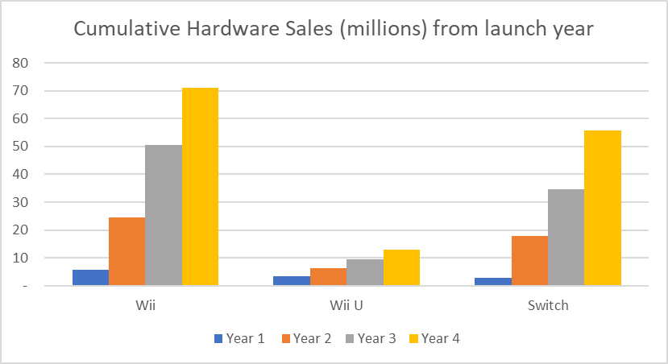

* + 1. A 2014 article in Forbes *(Tassi, 2014)* showed sales for the Wii U were down by a large margin. As an admission of the failure of the console, many Nintendo executives including current CEO Satoru Iwata took pay cuts of up to 50% as a symbolic gesture.

## Marketing Campaign

* + 1. One of the major reasons for the failure of the Wii U was due to its marketing campaign which launched at the Electronic Entertainment Expo in 2011 (Nintendo;IGN, 2011). The consoles announcement demonstrated the consoles main peripheral, the Wii U Gamepad. Due to this and the name was very similar to its predecessor, the Wii, many possible customers believed that the Wii U was simply an add-on to the Wii and did not believe it to be necessary to purchase the new console. With the price of the Wii U (cost £250-£300) being far higher than buying a Wii at the time (less than £150 new). Later adverts such as the “What is Wii U” marketing campaign tried to distinguish the Wii U from the Wii in an attempt to get them to upgrade to the new system as shown in a video by NintenDannNC (NintenDaanNC, 2012)). However, even with this ploy Wii U’s sales did not increase. The Wii U failed to show consumers that it was worth buying and ended with many third party companies refusing to work with them and eventually led to its downfall.

## Lack of new games

* + 1. Another reason for its failure was the systems lack of new games at both its launch and through its lifespan. At launch the Wii U had just 23 games and many of these games were re-releases from other consoles. The most appealing release for the system was New Super Mario Brothers U which was seen more as a HD expansion to the previous entry on the Wii New Super Mario Brothers Wii. While some new game releases such as Mario Kart 8, Donkey Kong Country Tropical Freeze and Super Smash Brothers for Wii U did sell well however, it was not enough to save the system in the long run.
    2. Later in the Wii U’s life span many third party game companies chose not to support the system due to both its previously mentioned failures in the market, its lack of power when compared to its competitors in the market at the time, and its over reliance to the Gamepad.

## Effect on Nintendo and future releases

* + 1. Many of the issues related to the release of the Wii U were resolved when Nintendo’s next home console the Switch was released. It was marketed as a separate entity from the Wii family of products and while its launch line-up was far smaller than the Wii U’s, many of the games were new products which could not have been played anywhere else e.g. 1-2-Switch. Nintendo also announced many more games to be released in the months following its release including many of those games being from third party developers and others being games re-releases from the Wii U which sold far more copies when compared to their original versions, one of these being Donkey Kong Tropical Freeze (Dring, 2018).

# Conclusions:

* 1. When comparing the PS1and the Wii U there are many similarities in their approach, such as the marketing of the controller. However, many of the differences between them show why one failed and the other succeeded.

## A new console

* + 1. The first was the difference was the approach to marketing the consoles as being new and different from others on the market. The PS1 was marketed as being a new console, having a new controller and even a new company entering the console market. This was in addition to the masses of new games developed by third-parties exclusively for the console. In contrast the Wii U was the successor to the Wii, marketing focused on the controller and the similarities in the names, the Wii U was seen as an add-on to the Wii as opposed to its successor.
    2. Nintendo learnt from this mistake and their next console, the Switch, was marketed as being a completely different experience from any of Nintendo’s consoles and easily overshadowed the Wii U in terms of sales.

## Third Party Support

* + 1. The approach to third party support was very different. For the PS1 third party games were considered to be its primary selling point, having thousands of new games. The Wii U on the other hand lacked third party games. This was due to its overreliance on the Wii U Game pad and its lack of power compared to its competitors at the time, the Xbox One and PlayStation 4.
    2. Overall, as found from the research conducted, many issues arise from the release of a new game or a console. However, its marketing as to how the game or console can be differentiated from others and the availability of new games are key at release.

## Bibliography

Big Ape Productions, 2001. *The Simpsons Wrestling.* PlayStation: EA.

Byrd, M., 2020. *The Evolution of the PlayStation Controller.* [Online]   
Available at: https://www.denofgeek.com/games/playstation-controllers-history/  
[Accessed 1 June 2020].

Dring, C., 2018. *UK Charts: God of War beats Donkey Kong to No.1.* [Online]   
Available at: https://www.gamesindustry.biz/articles/2018-05-07-uk-charts-god-of-war-defeats-donkey-kong-to-remain-no-1  
[Accessed 07 June 2020].

Google, 2005. *Youtube.* [Online]   
Available at: https://www.youtube.com/  
[Accessed 27 May 2020].

List Challenges, n.d. *All North American Release Playstation Games.* [Online]   
Available at: https://www.listchallenges.com/all-north-american-release-playstation-games  
[Accessed 2020 May 2020].

NintenDaanNC, 2012. *[Commercials] What is Wii U? - All Commercials.* [Online]   
Available at: https://www.youtube.com/watch?v=iOwIoWPGJwc  
[Accessed 27 May 2020].

Nintendo;IGN, 2011. *Nintendo Wii U Trailer (E3 2011).* [Online]   
Available at: https://www.youtube.com/watch?v=4e3qaPg_keg  
[Accessed 06 June 2020].

Nintendo, 2020. *IR Information : Sales Data - Dedicated Video Game Sales Units.* [Online]   
Available at: https://www.nintendo.co.jp/ir/en/finance/hard_soft/index.html  
[Accessed 31 May 2020].

Perry, D., 2001. *Simpsons Wrestling - IGN.* [Online]   
Available at: https://www.ign.com/articles/2001/04/06/simpsons-wrestling  
[Accessed 06 June 2020].

Petitle, S., 2020. *The Best PS1 Games of All Time | Digital Trends.* [Online]   
Available at: https://www.digitaltrends.com/gaming/best-ps1-games/  
[Accessed 07 June 2020].

Richer, F., 2020. *Chart: PlayStation 2 Is the Best-Selling Console of All Time | Statista.* [Online]   
Available at: https://www.statista.com/chart/18903/video-game-console-sales/  
[Accessed 07 June 2020].

Sony, n.d. *PlayStation | PS one | PlayStation.com.* [Online]   
Available at: https://www.playstation.com/en-gb/explore/ps1/  
[Accessed 31 May 2020].

Stewart, S., 2019. *Video game industry silently taking over entertainment world.* [Online]   
Available at: https://www.ejinsight.com/eji/article/id/2280405/20191022-video-game-industry-silently-taking-over-entertainment-world  
[Accessed 07 June 2020].

Tassi, P., 2014. *Wii U Sales Down 36%, Nintendo Executives Taking Pay Cut.* [Online]   
Available at: https://www.forbes.com/sites/insertcoin/2014/01/29/wii-u-sales-down-36-nintendo-executives-taking-pay-cut/  
[Accessed 31 May 2020].

Ukiepedia, 2019‎ . *Ukiepedia.* [Online]   
Available at: https://ukiepedia.ukie.org.uk/index.php/UK_Top_Selling_Games_2001  
[Accessed 06 June 2020].

# Appendices

## Appendix 1: PlayStation Controller

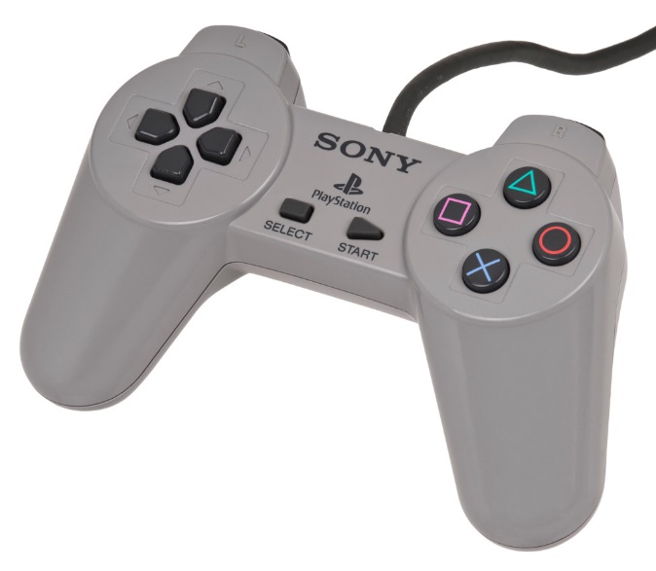

## Appendix 2: DualShock Controller

